Website Proposal
Student’s Name
Institution
Introduction
In the ever changing marketplace, online presence for businesses dealing with fashion and lifestyle products is essential. The reason for this is because many consumers are now spending most of their time online searching for products and the best deals. In fact, a study conducted by () showed that 81 percent of shoppers tend to take on the Internet to do their research while finding the best deals before they make the decision to purchase anything. On average, a consumer tends to visit three stores before making a purchase. The period in which people used to visit physical or offline stores to pick up things is over. Therefore, companies like Buoy Clothing need to develop an e-commerce website that will help in showcasing products and accept orders even when customers are shopping at odd hours or when physical stores are shut. An online shop will make life simpler for many customers especially those who have time constraints to visit an offline store to pick up things they want. Helping Buoy Clothing Company develop an interactive e-commerce website is the aim of this proposal.
Industry Analysis
One thing to note here is that fashion and lifestyle industry is changing at a lightning speed in terms of latest trends. Therefore, companies operating in this industry need to absorb fashion and lifestyle changes to ensure that they remain in a competitive edge. This behaviour is also typical when it comes to how their websites should be designed as customers expect to see a blend of latest visual and technological trends.
Buoy Clothing is not performing fairly since there are many other companies that are selling similar products. Also, other companies seem to be far ahead of Buoy Clothing simply because it has not upgraded its website. Other fashion companies that rely on the power of e-commerce websites seem to be drawing more customer attention while they use product visuals to speak for themselves. According to Park & Kim (2003), 81 percent of fashion and lifestyle consumers agree that they tend to search for products online before even they think of purchasing them from fashion stores.
Performance of a fashion company depends on the marketing strategies it employs in a specific market segment. According to McKinsey Global Fashion, the big winners in the fashion industry are likely to be those companies that are ready to improve the way they have been marketing themselves because at the moment the industry is driven by fad. Companies that are capable of creating high-quality websites and mobile apps are more likely to increase their profits by 3.0 to 4.0 percent (McKinsey Global Fashion, n. d). Because of these predictions, it is important to help companies like Buoy Clothing develop an e-commerce website it can use to leverage the power of online presence.
PESTEL Analysis
When deciding whether or not to create an online presence, businesses also need to take into account government policies as well as political stability. Government policies, for example, policies established to regulate competition could have a negative impact on businesses that do not have strategized ways for competing with other rival companies. Political stability can also have a negative impact on physical stores especially when a country is experiencing some political chaos. In such a scenario, customers would have difficulties accessing physical stores but could access an online shop hence making the business even more viable.
Today, businesses are continuing to experience a boom of new technologies especially in the fashion sector. Technological advances have enabled an improvement in economic transactions making it even easier and faster for customers to transact. A company that is unwilling to embrace the power of e-commerce is more likely to lag behind in terms of revenue generated and even experience difficulties gaining market share in a competitive marketplace. Therefore, an e-commerce website would provide a remarkable source of competitive advantage to businesses like Buoy Clothing that are struggling to overcome economic issues. This is even so because in coming years the ability to generate increased revenues will heavily depend on the business’s ability to adopt new technologies that will be innovated for enhancing business transactions.
When looking at social factors that are likely to affect the business, it is important to look at things like lifestyle choices and the expectations customers have on a particular business. Many fashion businesses are using technology to provide a seamless experience, for example, many are developing e-commerce platforms on which customers can view products and even match their preferences. With more shoppers making purchases online, it is important to have an e-commerce website that allows them to give more details about themselves. For example, an e-commerce website for a fashion business should integrate features that allow shoppers to give more details about themselves e.g. their size, height, and so forth to ensure that they do not purchase products that do not fit them. Technology has grown exponentially and the ways in which Buoy Clothing Company is responding to technological innovation is of paramount consideration. It needs to enhance the website’s security levels and increase storage to ensure that it keeps a record of its customers.
Situational Analysis
Understanding the current market characteristics is instrumental in the business ability to carry out its marketing objectives. Because Buoy Clothing is located at an area with direct competition from other fashion businesses, it is important to consider both pros and cons to be considered when designing the website.
Buoy Clothing Company is competing with a large number of fashion companies that are located in close proximities which also makes it difficult for the company to generate enough profits. Rival companies have great e-commerce websites that are fully functional. Also, these companies seem to target millennials as their potential customers. Therefore, when developing Buoy Clothing Company website the web developer will focus more on what this population wants, and how much it will cost to maintain the website so as to keep up with new technologies.
One thing to understand here is that fashion companies are mainly targeting Millennials because this target population is continuing to change how people used to do their shopping. According to a latest study done by Forbes.com, Millennials have a reputation for searching products and making most of their purchases online using their smartphones. This means that fashion companies need to develop online shops that are user friendly. According to Delone & Mclean (2004), making a website user friendly is not all about making it functional but making it responsive. As discussed later, the Buoy Clothing website is not responsive enough and, therefore, the web developer will try to improve it by making it mobile-optimized.
Company Overview
Buoy Clothing is a fashion business that was established in mid 2015. It was established in Okanagan Valley to provide high-quality and comfortable clothing. The company was started by two entrepreneurs who are passionate in fashion and lifestyle. They work together as business partners to ensure they achieve both long-term and short-term goals for the company.
Mission Statement
Buoy Clothing is a fashion company dedicated to providing high-quality and comfortable clothing made in Melbourne. The company is also dedicated to creating a memorable experience for those who commit their time and resources to shop with us.
SWOT Analysis
Buoy Clothing Company’s Strengths
Almost everyone in Okanagan Valley knows its brand. Therefore, it is most likely to have brand recognition for selling clothes made in Melbourne. This could be an advantage compared to other fashion companies that had been selling locally made products. Therefore, the ability for Buoy Clothing to offer differentiated products is a strength the company can leverage. Clients are more likely to love Melbourne products because they are unique. The company is capable of opening various outlets around the world that will be operated within a centralized system. This is a strong advantage because it would be able to sell its products overseas. Through a well designed online store, the company can be able to chose its customers carefully hence targeting its products to the most relevant market segment.
Weaknesses
Buoy Clothing have not invested well in its online store. Therefore, it is unable to compete with new entrants in the fashion industry. New entrants are coming up with great innovations that are improving customer experience hence using the strategy to generate more revenues from their online stores. Also, Buoy’s current website is not customized to attract targeted customers who are more concerned with fad and quality. For customers like Millennials, this is an issue as they prefer shopping on platforms that are interactive and easy to use.
Opportunities
In terms of opportunities, Buoy Clothing Company can use an online store to access fashion markets all over the world. It simply has to apply a working business model that leverages online opportunities. In fact, emerging markets could be a great source of growth for the company (Goldenberg, 2015).
Threats
One of the greatest threats for Buoy Clothing Company is the saturation of the fashion market. Consumers are now shopping from online stores they perceive as best. Most fashion companies are better position to ship products overseas e.g. Amazon that also has an online fashion store. This is a great to Buoy Clothing Company because customers are more likely to purchase from an already established brand they know well.
Competitive Analysis
Buoy Clothing competitors seem to be investing more in high innovation. This is because people are no longer doing their shopping from physical stores. Think of a customer who saw a nice dress in a certain store, but decided to purchase a similar dress online simply because it was discounted. The same applies to other competitors who have realized the power of online presence. In fact, most of Buoy Clothing rivals have already created great online stores and are also using social media to market their products.
Compared to other competitors in the fashion industry, Buoy Clothing Company seems to be far behind due to its low innovation. Therefore, it has been unable to compete in the crowded fashion market. To thrive in the industry, Buoy Clothing needs to find a unique value it can use to differentiate its business from others. It also needs to focus on a niche market where it offers high-end user experience.
When shopping around, consumers are always looking for the best options online or even talk to friends and family members about their past purchasing experiences. When making the decision to purchase though, they tend to narrow down their long list into the very important shortlist of the three. With this understanding, Buoy competitors have been trying their best to make sure their companies make to the buyer’s shortlist. That is why understanding the rule of three is fundamentally important to Buoy Clothing’s marketing strategies as customers are always looking for reasons to rule out. Therefore, a great online store that meets all customer requirements could help the company not to be ruled out. The following is a screenshot of a great online store.
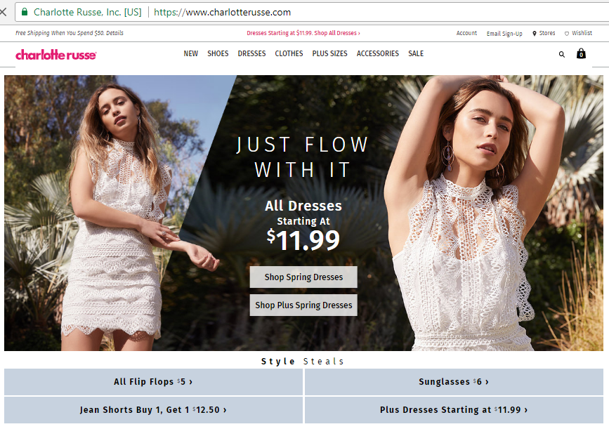
https://www.charlotterusse.com/
Customer Analysis
Recent studies have shown that today’s fashion retailers are targeting millennials who tend to spend most of their time on mobile devices. In fact, a study conducted by Hall & Towers (2017) found that 45 percent of millennials tend to spend an hour or more per day shopping online. This means that if a business does not increase its online presence, it is more likely to be left behind and even find it difficult to compete with competitors who are already leveraging online. Goldenberg (2015) discusses about how businesses are now using the idea of technographics to increase sales. He defines “technographics” as a trend in which people use technologies to get the things they need rather than finding them from physical stores (Goldenberg, 2015). Millennials fall under the category of people who are mostly using social media to find things they want. They also spend most of their time matching prices from different online stores before they make a purchase (Goldenberg, 2015). Therefore, designing an e-commerce or an online store is the biggest step a business can make towards generating increased revenues.
Project Proposal
The Need for Website Improvement/Problems with the Current Website
The reason why Buoy Clothing should improve its website is because an improved e-commerce website can help the company fuel sales. As discussed earlier, consumer shopping behaviours are changing at an alarming rate. While Buoy Clothing website may appear enticing to the eyes, its functionality needs to be improved so as to improve user’s experience. Traditionally, websites were designed without necessarily putting user’s experience in mind (Garrett, 2010).
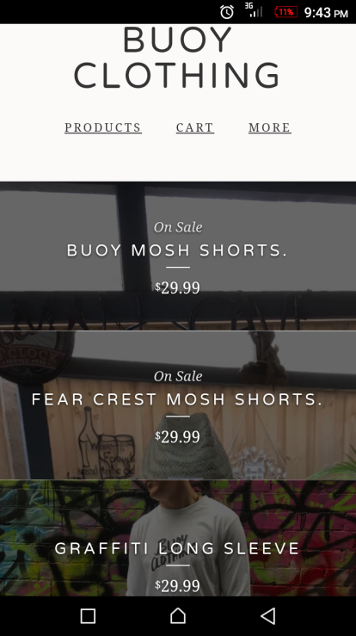
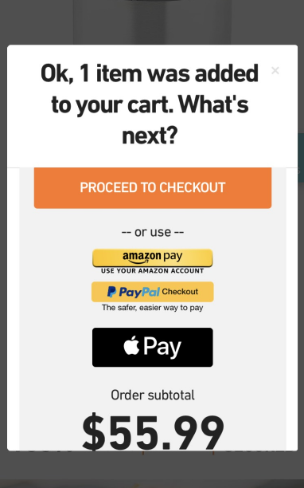
One problem with the website “buoyclothing.com” is that it is not responsive as one cannot view it properly on mobile devices. When viewed on a smartphone, the website seems disorganized, product pictures are overlapping, and one cannot trace where the checkout button of the shopping cart is located. (See screenshot 1 below.)
Screenshot 1: Buoy Clothing
Screenshot 2: Payment Gateway
Making the website responsive is critical if the company will ever make sales on it. This is because thousands of shoppers are doing their shopping online and would like a website that makes their shopping experience more interactive. In fact, an interactive e-commerce website should not necessarily take the customer to a shopping cart like buoyclothing.com does, but can integrate a pop-up feature that tells the customer what to do next as shown on the screenshot 2 above.
Also, buoyclothing.com also makes it difficult for the customer to navigate from one product to the other. Therefore, the website needs to be edited to ensure that customers can search and find products they want to purchase more easily. Therefore, the website needs some product categorization to improve user experience.
It is also important to note here that buoyclothing.com is competing with great brands that have already turned their websites into landing pages with great user experience. Therefore, it is important to create more optimized content that helps in marketing the products online. Online marketers talk about search engine optimization which is the development of more optimized content that uses key words to promote a website on search engines. Therefore, Buoy Clothing Company needs to turn its product pages into SEO-optimized landing pages to ensure that products are easily seen on search engines.
Argument
With the increasing rate of online shopping, companies like Buoy Clothing need to develop responsive websites that are easily accessible on mobile devices as many shoppers are now shopping online rather than from physical stores. A well designed e-commerce website should also make it easy for users to make purchases and should be integrated with a payment gateway to allow shoppers make payments for products they have ordered. Products should also be categorized as per their attributes to improve user experience. By designing a website that meets all these requirements, companies like Buoy Clothing would attract even more online customers hence increase its profits.
Critical Evaluation of Amazon Website
Amazon is an online store that had been dealing with a variety of products. Like any other fashion company, it also deals with all types of clothes. The online shop is well organized and one of the most important aspect that has enabled it achieve greater success is the organization of its products. Products are organized into categories. For example, to purchase clothing products, the user has to select the department “Clothing, Shoes & Jewelry” and then chose the category of interest e.g. “The Women Shop” if one wants to purchase a skirt, blouse or anything else meant for women. “The Women Shop” is further arranged into categories to allow shoppers search by category for products they want. For example, they can shop by occasion, style, influencer’s pick, brands and so forth. (See the following screenshot 3: Amazon Fashion Store)
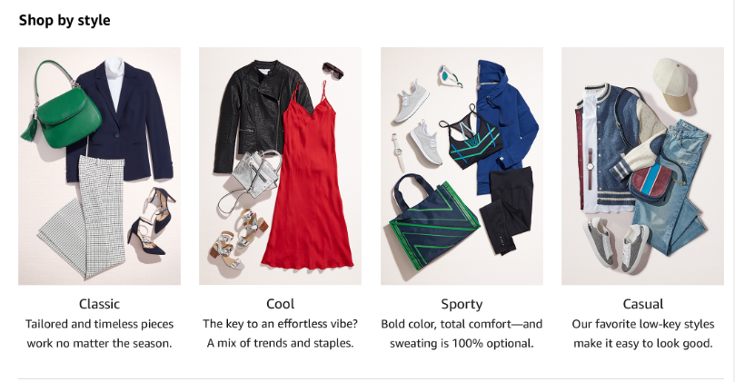
By arranging products into categories, Amazon makes shopping experience enjoyable and even more convenient as customers can easily find what they want. The website is also using filters to ensure that customers can easily search for products they do not see on the front page or even filter products by size, color and so forth.
Description of the Optimal Website to Be Created
As discussed earlier, the aim is to help Buoy Clothing Company develop a more responsive online store. The store will be designed on an e-commerce platform to ensure proper functionality. It is also important to note here that the design will be prototyped to ensure that it harmonizes things like simplicity, beauty, consistency, and symmetry. To achieve all these, the web designer/developer will use a combination of new web technologies to complement and engage user interface (UI) with an intuitive user experience (UX).
Home Page (Full Page Layout)
A high-quality design will incorporate various features that will improve how users had been interacting with the website. The homepage of the website will include pictures that will be used to invoke customer’s emotions. The web developer will optimize the homepage by using interactive graphics that will be placed on a slider. The entire slider will help bring clarity while attracting users who will enjoy navigating through the website to learn more about it. This is even so because customers visiting an online store tend to get their first impression from the visual elements and layout. Therefore, some images of featured products will be incorporated in the slider to ensure that users resonate with the website even before they proceed to the product pages or the shopping cart. A “SHOP NOW” button will also be included on the left side of the slider to help users navigate the site. The button will be hyperlinked to ensure that when clicked it will direct users to the product landing pages.
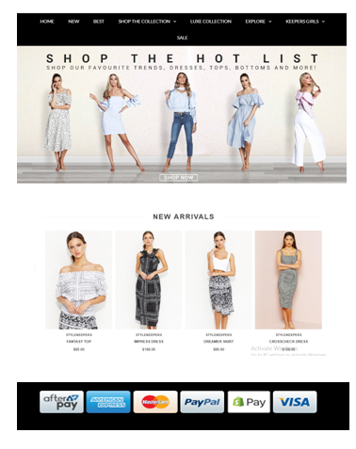
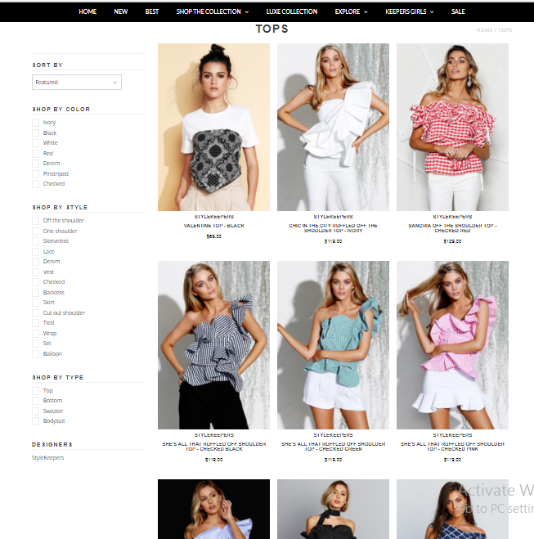
A content block will also be created below the homepage. The block will contain some “exclusive products” featuring some of the most popular and creative brands. The entire section will be used to attract even more customers who would be interested in purchasing various products, but do not have time to navigate all over the website searching for them. The following is a screenshot demonstrating how the homepage and product pages would appear.
Screenshot: Homepage
Screenshot: Product Page

Product Pages
As described earlier, product pages are the heart of any online store. Therefore, the structure or layout of a product page should be well organized to ensure that customers get a positive experience when searching for products they want to purchase. Product pages will be kept simple but will be designed in a way that will help feature different product categories. As demonstrated in the product page above, products will be categorized to improve user interactivity. Also, categories will be included in the sidebar to ensure that customers search or even sort products by style, color, size and so forth.
Payment Gateway
Designing a beautiful e-commerce website, improving customer experience, and providing the best product categories to convince customers to continue browsing for products and perhaps push them to a purchase funnel are all important for any online shop. While all that make sense, it is important to note here that a payment gateway makes all the difference. Customers may select products they want to purchase but find it difficult checking out to complete the transaction. Therefore, a digital wallet will be integrated to make payment even easier. The wallet will allow one-click purchasing to make payment less annoying. Payment gateway will include integration of: Pay, Master Card, PayPal, Visa Checkout just to mention but a few.
User Validation Feature and Contact Page
It is also important to note here that not all customers who reach the checkout stage are likely to complete the purchasing process. Therefore, integrating an email feature that captures their contact would help the company reach out to such customers in future whereby it will use captured contacts to send offers and newsletters.
How the Website Fits with the Organization’s Business and Revenue Models
The new website will fit with the organization’s business and revenue models because it will have all features that allow a business to generate revenues online. As explained above, it will incorporate product pages where products will be categorized as per their attributes. Product categorization is important in businesses because it is a way of helping customers easily find whatever they want to buy. Liu et al (2017) explain that product categorization not only help consumers evaluate products, but also classifies a brand in their minds something that plays a role in how they evaluate the products. Integration of a payment gateway also makes the website fit with the business revenue model because the website is not only designed to attract potential customers but convert them into buyers. The ability to transact online will increase revenues for the business.
Measures/Metrics for Evaluating Success of the Project
One of the best ways for measuring success of the website is through the analysis of traffic generated. The web designer will make sure that the website is well optimized to increase its online visibility. According to Patil et al (2015), content need to be optimized to ensure that it appears on search engines. Therefore, search engine optimization will be part of the tasks conducted to improve the website. Other metrics to be used include: bouncing rate, the average time customers spend on the website, evaluation of CTA Clicks, conversion rate, as well as revenue generated through the website.
Conclusion
The key to a successful online business is making things simple as possible. An e-commerce website should be interactive, responsive, and easy to navigate. Customers should be able to search, select, and add products to cart. The process should render good customer experience. An annoying process tends to impact customer’s journey to making a purchase hence resulting to abandoned carts. Therefore, for a business to grow sales it must ensure that its online shop is not only attractive, but well organized, interactive, easy to use, and responsive in all devices.
It is also important to note here that businesses need to develop mobile apps to ensure that consumers can acquire more about their products from the comfort of their mobile devices. For example, a one-stop-mobile app can help Buoy Clothing create an integrated experience based on consumer preferences. Consumers can use the mobile app to acquire more about products or even check shipping status of the products they have purchased.

References
Delone, W. H., & Mclean, E. R. (2004). Measuring e-commerce success: Applying the DeLone & McLean information systems success model. International Journal of Electronic Commerce, 9(1), 31-47.
Garrett, J. J. (2010). The elements of user experience: user-centered design for the web and beyond. Pearson Education.
Goldenberg, B. J. (2015). The definitive guide to social CRM: Maximizing customer relationships with social media to gain market insights, customers, and profits. Pearson Education.
Hall, A., & Towers, N. (2017). Understanding how Millennial shoppers decide what to buy: Digitally connected unseen journeys. International Journal of Retail & Distribution Management, 45(5), 498-517.
Liu, Y., Li, K. J., Chen, H., & Balachander, S. (2017). The Effects of Products’ Aesthetic Design on Demand and Marketing-Mix Effectiveness: The Role of Segment Prototypicality and Brand Consistency. Journal of Marketing, 81(1), 83-102.
McKinsey Global Fashion (n. d). The State of Fashion. Retrieved from < https://www.mckinsey.com/industries/retail/our-insights/the-state-of-fashion>
Park, C. H., & Kim, Y. G. (2003). Identifying key factors affecting consumer purchase behavior in an online shopping context. International journal of retail & distribution management, 31(1), 16-29.
Patil, D. M., Jadhav, K. M., & Patil, M. G. (2015). A study on Search engine and Search Engine Optimization. International Journal of Advance Research in Computer Science and Management Studies, 3(6).

